Power Electronics

Buck Converter Circuit

Hyunui Park&Gyeonheal An, Automotive Mania Group (AMG)

04/30/23

***Abstract* - This report focuses on designing circuits through direct experiments on buck converters and comparing their results to understand the operating principle and loss of buck converters. The buck converter is used to obtain an output voltage lower than the input voltage. This is due to the operation of an element having a rated voltage lower than the DC voltage input through power conversion. In a buck converter, MOSFET and Diode perform the switching operation, and through the LPF filter of the inductor and capacitor, power loss is reduced. In addition, the oscilloscope change was understood through duty adjustment using variable resistance to the input/output voltage relationship of the buck converter. In addition, we studied the reason for using Bootstrap, which makes the voltage difference between Vgs and Vds inside the MOSFET device, and studied the loss of the output voltage of the buck converter depending on the presence or absence of Bootstrap.**

# Introduction

W

e use electronic devices that require an output voltage lower than the input voltage in real life. For example, the output of a battery used in a car is 12V and 24V, but the voltages used in a cigar jack are 5V and 9V. The USB voltage of the laptop is also lowered and inputted.

At this time, the output voltage is lowered using the Zener diode, voltage distribution due to resistance, and the linear method. However, these circuits have the disadvantage of high voltage loss due to heat and low efficiency.

However, buck converters have advantages in terms of power/efficiency/space/weight. In the buck converter, the MOSFET generates an output voltage by performing a fast frequency switching operation on the input PWM signal. In this case, when the duty on which the MOSFET is turned on is adjusted, the output voltage is also adjusted. At this time, when the MOSFET is On, a loss due to internal resistance occurs, which can be reduced by using a Bootstrap device. The voltage difference between the gate and source terminals of the MOSFET requires a high voltage of 12V or greater. By supplying the boosting voltage required by the Bootstrap to the MOSFET gate driver, the loss caused by the internal resistance of the MOSFET can be reduced and power consumption can be minimized to further increase the efficiency of the Buck Converter.

To confirm this, the amount of power loss according to the presence or absence of the bootstrap was compared, and a direct circuit was designed to help understand the Buck converter circuit, and the output of the changing Buck Converter was tested by changing the Duty and frequency.

# Principle of Buck Converter Operation

**Figure 1. Circuit of Buck converter**

1. Understanding Buck Converter Components

As shown in Figure 1, a buck converter is basically composed of a switching device (MOSFET), a diode, an inductor, and a capacitor.

Firstly, the Buck converter is basically voltage-dropped by the switching of the MOSFET.

**Figure 2. Structure of MOSFET**

MOSFET(Metal-Oxide-Semiconductor-Field-Effect-Transistor) is one of the widely used semiconductor devices in electronics and integrated circuits. MOSFET is a popular component in electronics and integrated circuits due to its low power consumption, fast switching speed, and high gain.

MOSFET is essentially composed of two PN junction diodes. PN junctions come in two types: p-type (positive-negative) and n-type (negative-positive), and MOSFET uses p-type PN junctions. The gate is used to control this p-type PN junction.

By applying a voltage to the gate-source junction, a channel is formed in MOSFET due to the electric field generated at the gate. This channel is made up of a metal-oxide-semiconductor structure between the two p-types PN junctions. The current flowing through this channel is controlled by the voltage applied to the gate-source junction.

One of the characteristics of MOSFET is that the charge carriers in the channel can move freely without any resistance. This makes MOSFET more power-efficient, faster, and has a higher input impedance than most other semiconductor devices.

The switching principle of MOSFET in buck converters is that when a positive voltage is applied to the gate terminal, the electrical disconnection is released through the thin oxide film between the gate and the source and the current flows. Switching can be performed by cutting it off by applying less voltage.

**Figure 3. PN junction Diode**

Secondly, diode is a semiconductor device used to allow or block the flow of electricity. It is commonly known as a P-N junction diode, and has two terminals, one for the anode and the other for the cathode.

A P-N junction diode is composed of a junction between a P-type semiconductor and an N-type semiconductor. The P-type semiconductor has a shortage of electrons, while the N-type semiconductor has an excess of electrons. The P-N junction diode exhibits different characteristics depending on the direction of the current flow, whether it allows or blocks the flow of current.

In the anode terminal, electrons move from the P-type semiconductor to the N-type semiconductor, allowing current to flow. This is the "conducting state" of the diode. However, in the cathode terminal, electrons cannot move from the N-type semiconductor to the P-type semiconductor, thus preventing the flow of current. This is the "blocking state" of the diode.

The switching behavior of MOSFET in buck converter has a close effect on diode. When the MOSFET is on, energy is accumulated as a current flows through the inductor. When the MOSFET is off, the accumulated energy from the inductor is transferred to the output via the diode.

The role of the diode is to smooth the energy accumulated in the inductor to stabilize the output voltage. When the MOSFET is off, the current from the inductor to the output flows through the diode. At this point, the diode acts as a rectifier and stabilizes the output voltage by reducing the switching noise.

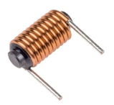

**Figure 4. Inductor**

Thirdly, the inductor is an electrically charged coil that controls current and stores and transfers energy. In a Buck Converter, the inductor accumulates current when the input voltage is on and delivers the accumulated current to the output when the input voltage is off, thereby stabilizing the output voltage.

This principle is based on the magnetic field of the inductor and the way current changes. When current passes through the inductor, a magnetic field is created, and when the current stops in the inductor due to resistance, it induces a voltage that is used to maintain and stabilize the output voltage.

**Figure 5. $v_{L}$ and $i_{L}$ under switch operation**

Through Figure 5 above, we can derive the following equation.

Inductor defining relation:

$$v_{L}=L\frac{di_{L}(t)}{dt}$$

Integration over one complete switching period:

$$i_{L}\left(T_{s}\right)-i_{L}\left(0\right)=\frac{1}{L}\int_{0}^{T_{s}}{v_{L}\left(t\right) dt}$$

In periodic steady state, the net change in inductor current is zero:

$$0=\int_{0}^{T_{s}}{v_{L}\left(t\right) dt}$$

$$0=\frac{1}{T_{s}}\int_{0}^{T_{s}}{v_{L}\left(t\right) dt}=<V_{L}>$$

This is called inductor volt-second balance.

In the voltage waveform of an inductor whose period is $T_{s}$, when $DT_{s}$ and when $D^{'}T_{s}$, the waveform of inductor area is as follows.

$$λ=\int_{0}^{T_{s}}{v_{L}\left(t\right) dt}={(V}_{g}-V)(DT_{s})+(-V)(D^{'}T_{s})$$

Average voltage is:

$$<v_{L}> =\frac{λ}{T_{s}}=D\left(V_{g}-V\right)+D'(-V)$$

Equate to zero and solve for $V:$

$$0=DV_{g}-\left(D+D^{'}\right)V=DV_{g}-V$$

$$V=DV_{g}$$

The Volt-second balance allows us to know the ideal voltage input/output relationship of the Buck converter.

As shown in figure 5, the inductor current goes between $i_{L,min}$ and $i_{L,max}$, and if the inductor current is less than or equal to $0[A]$, the buck converter will deviate from the CCM operation. Therefore, $i_{L,min}$ must be greater than $0[A]$ for CCM operation.

Next, through figure 5, we can derive the ripple value of the inductor current through the following equation.

$$\frac{di_{L}}{dt}=\frac{∆i_{L}}{{DT}_{s}}=\frac{V_{in}-V_{out}}{L}=\frac{∆i_{L}}{\left(1-D\right)T_{s}}=\frac{V_{out}}{L}$$

$$∆i_{L}=\frac{V_{in}-V_{out}}{Lf}D=\frac{V_{out}\left(1-D\right)}{Lf}$$

If we apply the conditions of the CCM mentioned earlier

$$i_{L,avg}≥\frac{∆i_{L}}{2}, 2i_{L, avg}≥∆i_{L}$$

$∆i_{L}$ becomes its maximum value when $D=0.5$

$$∆i_{L,max}=\frac{V_{out}}{Lf}×\frac{1}{2}$$

$$i_{L}, avg=I_{out}≥\frac{V_{out}}{4Lf}$$

If we derive a suitable inductor size expression:

**Figure 6. Structure of Capacitor**

Fourthly, a capacitor is used to reduce the difference between the input and output voltages of the Buck converter. The Capacitor detects changes in current very quickly and can temporarily maintain voltage. At this point, the current decreases while the Capacitor is being charged, so the voltage decreases. Accordingly, the input that enters the square wave is output as a flat DC voltage due to the capacitor. Therefore, the Capacitor improves the output voltage stability of the converter by stabilizing the voltage and reducing high frequency noise.

In addition, in Buck converter, the Capacitor is used to reduce power loss. When the MOSFET is turned off and the current decreases in the transducer, the Capacitor emits energy and uses this energy to maintain the output voltage of the transducer. This reduces the power consumed by the transducer and improves power efficiency.

Also, the Capacitor is used to reduce the noise of the switching device. In Buck converter, the switching device operates at high frequencies, resulting in noise. This noise can compromise the stability of the circuit. The Capacitor absorbs noise from the switching device and improves circuit stability by reducing noise in the circuit.

**Figure 7. Waveform of $V_{c}, I_{c}$**

If the ripple of $V_{c}$ is very small, then all the ac component of inductor current flows through the capacitor.

As we can see in Figure 7, the positive current causes the capacitor voltage to increase between its minimum and maximum extrema. During this time, the total charge q is deposited on the capacitor plates, where

$$q=C(2∆v)$$

The total charge q is the area of the triangle:

$$q=\frac{1}{2}∆i_{L}\frac{T_{s}}{2}$$

Then we can solve for $∆v:$

$$∆v=\frac{∆i_{L}T_{s}}{8C}$$

Therefore, the ripple voltage expression of the capacitor in the buck converter may be derived through the corresponding expression. Therefore, by adjusting the capacitor value, we can adjust the ripple value and reduce the loss of the output voltage.

The LC circuit using the inductor and capacitor is used as a low pass filter, which plays a role in reducing loss by removing high-frequency noise of the output voltage at the buck converter.

The capacitor responds quickly to changes in voltage but slowly to changes in current, while the inductor responds quickly to changes in current but slowly to changes in voltage.

By utilizing these characteristics, an LC circuit can block or pass electric signals at a specific frequency.

**Figure 8. Low pass filter Circuit**

The impedance of the inductor and capacitor is as follows:

$$X_{L}=jωL, X_{C}=\frac{1}{jωC}$$

The input/output relationship of the low pass filter is as follows.

$$\left|\frac{V_{out}}{V_{in}}\right|=\frac{\left|X_{C}\right|}{\left|X_{L}+X_{C}\right|}=\left|\frac{1}{\sqrt{1+(ωL)(ωC)}}\right|=\frac{1}{\sqrt{1+ω^{2}LC}}$$

$$f_{c}=\frac{1}{2π\sqrt{LC}}$$

The output voltage is controlled by MOSFET switching element. During switching operation, there can be transient voltage and current variations in the inductor and capacitor. These variations can cause ripple in the output voltage.

To reduce this ripple, the LC filter in a Buck converter acts as a low pass filter. The LC filter blocks high frequency signals while allowing low frequency signals to pass through. Therefore, the LC filter plays an important role in reducing output voltage ripple and maintaining a stable DC voltage in a Buck converter.

Typically, the LC filter is applied on the output side. The capacitor is connected in parallel with the load (R) to remove ripple voltage and provide a stable DC voltage. The inductor is connected with the capacitor, where low frequency signals pass through the capacitor to the load, and high frequency signals are blocked by the inductor.

1. Understanding Buck Converter Operation

**Figure 9. Original Buck Converter**

**Figure 10. SW in position 1**

When the switch is on position 1, the input voltage charges the inductor, causing the inductor current to increase. At the same time, the charged voltage is delivered to the output through a diode. If there is an output load connected, the voltage is supplied to the load.

Inductor voltage is as follows.

$$v_{L}(t)=V_{g}-v(t)$$

If we apply the law of small approximation.

$$v_{L}(t)≅V_{g}-V=L\frac{di_{L}\left(t\right)}{dt}$$

Solving for the slope:

**Figure 11. Operation of Buck Converter(On-state)**

Through this, it can be confirmed that an inductor current graph such as figure 11 can be drawn when the switch is on.

**Figure 12. SW in position 2**

When the switch is on position 2, the energy of the inductor is supplied to the output load through the diode. The inductor current decreases, and the output voltage is maintained.

Inductor voltage is as follows.

$$v_{L}(t)=-v(t)$$

If we apply the law of small approximation.

$$v_{L}(t)≅-V=L\frac{di_{L}\left(t\right)}{dt}$$

Solving for the slope:

**Figure 13. Operation of Buck Converter(Off-state)**

Through this, it can be confirmed that an inductor current graph such as figure 13 can be drawn when the switch is off.

However, the above equation is the operation of the Ideal Buck converter without considering the internal parasitic capacitance of MOSFET. Considering the internal parasitic capacitance, the voltage at the MOSFET gate terminal may not exceed the threshold voltage. Therefore, to reduce the loss of this, we solve it using a bootstrap element.

**Figure 14. An example of a Bootstrapping circuit**

The bootstrap circuit is composed of a capacitor and a diode and is used to increase the MOSFET gate drive voltage. The gate of the MOSFET is controlled through the gate-source capacitor, and the gate voltage must be maintained at a sufficient level during switching operation. However, the parasitic capacitor inside the MOSFET may cause slow charging and discharging due to its high frequency characteristics, which can result in insufficient gate drive voltage.

The bootstrap circuit solves this problem by using a capacitor to increase the gate voltage. The capacitor in the bootstrap circuit is charged based on the output load voltage. When the MOSFET switch is turned ON, the diode is reversed, and the capacitor voltage is maintained by connecting the charged capacitor voltage to the output load voltage. This maintained capacitor voltage is used as the MOSFET gate drive voltage.

**Figure 15. Charging capacitor during operation**

**Figure 16. Charged capacitor provide extra voltage.**

The operation principle of the bootstrap circuit is as follows:

1. When the MOSFET switch is in the OFF state, the capacitor is charged by the output load voltage. (Figure 15)
2. When the MOSFET switch is turned ON, the gate-source capacitor of the MOSFET tries to maintain the charged capacitor voltage. (Figure 16)
3. As the output load continues to consume current, the output load voltage decreases. However, the MOSFET gate voltage is maintained since the gate-source capacitor is already charged.
4. When the MOSFET switch is turned OFF again, the gate-source capacitor of the MOSFET is recharged with the capacitor, and the process repeats.
5. Discussion Problems

|  |  |  |  |  |  |
| --- | --- | --- | --- | --- | --- |
| **Table 1. Parameters of a Buck Converter** | | | | | |
| Parameter | $$V_{in}$$ | $$L$$ | $$C$$ | Duty | $$f_{osc}$$ |
| Value | 10[V] | 330[ $μH]$ | $$330[μF]$$ | 0.5 | $$100[kHz]$$ |

We drew the wave forms required by the problem below through simulation of the PSIM program with the experimental conditions shown in the table above.



**Figure 17. Circuit of Buck Converter (PSIM Simulator)**

1. Drawing wave forms

**Figure 18. Voltage of Diode**

The voltage of the diode is applied when it is turned on by MOSFET switching, and the voltage becomes 0 when it is turned off.

**Figure 19. Current & Voltage of MOSFET**

In the MOSFET, when a voltage is applied to the gate, the drain source voltage becomes 0. And if the voltage is not applied to the gate, the voltage at the drain source stage becomes the input voltage. Conversely, when a voltage is applied to the gate, the current at the drain source stage has a value, and when a voltage is not applied to the gate, the current at the drain source stage becomes 0.

**Figure 20. Current & Voltage of Inductor**

The voltage of an inductor becomes positive as the current flowing through the inductor increases, and it becomes negative as the current flowing through the inductor decreases.

**Figure 21. Current & Voltage of Capacitor**

The current of the capacitor is output as a triangular wave and the voltage is output as a sinusoidal wave.

**Figure 22. Current & Voltage of $R_{Load}$**

This is because the voltage and current applied to the resistance of the output terminal are output as sinusoidal waves, passing through the LC circuit.

1. Drawing wave forms

**Figure 23. Conditions of Problem 2**

***

**Figure 24. wave form of $V_{L}$**

1. The capacitor current $i_{C}$, shown in Fig., is flowing through a capacitor of $100[μF]$. Calculate the peak-peak ripple in the capacitor voltage waveform due to this ripple current.

**Figure 25. Conditions of Problem 3**

$$∆Q=\frac{1}{2}\left(\frac{∆i_{L}}{2}\right)∙\frac{T}{2}=C∆V$$

$$∆V=\frac{1}{C}\left(∆i_{L}\right)∙\frac{T}{8}=\frac{1}{100\left[μF\right]}∙1\left[A\right]∙\frac{{\left(5\left[μs\right]\right)}^{2}}{8}=6.25[mV]$$

1. From the PSIM Circuit of the Buck Converter, L= $24[μH]$. It is operating in dc steady state under the following conditions: $V_{in}=20\left[V\right], D=0.6, P_{out}=14\left[W\right], f=200[kHz]$. Assuming ideal components, calculate and draw the waveforms of the inductor current and voltage.

**Figure 26. wave form of**

**Figure 27. wave form of $I_{L}$**

$$V_{out}=V_{in}∙D=20\left[V\right]×0.6=12[V]$$

$$I_{L}= I_{out}=\frac{P_{out}}{V_{out}}=\frac{14[W]}{12[V]}=1.1667[A]$$

$${Δi}_{L} = \frac{V_{out}(1-D)}{Lf} =\frac{12\left[V\right] (1-0.6)}{24[μH]×200[kHz]}=1[A]$$

$$I_{max}= I_{L}+\frac{Δi_{L}}{2} = 1.1667\left[A\right]+0.5[A] = 1.6667[A]$$

$$I_{min}= I_{L}-\frac{Δi_{L}}{2} = 1.1667\left[A\right]-0.5\left[A\right] = 0.6667[A]$$

1. In a Buck dc-dc converter, L= $25[μH]$. It is operating in dc steady state under the following conditions: $V_{in}=42\left[V\right], D=0.3, f=400[kHz]$. Assume ideal components. The output load is changing. Calculate the critical value of the output load $R_{Load}$ and $P_{out}$ below which the converter will enter the discontinuous condition mode of operation.

DCM Condition: $I_{min}≤0$

$$I_{min} = 0 ≤ V_{out}\left(\frac{1}{R}-\frac{1-D}{2Lf}\right)$$

$$R_{Load} ≤ \frac{2Lf}{\left(1-D\right)}≤28.5714[Ω]$$

$$V = {DV}_{g}=12.6\left[V\right]$$

$$P_{out}=\frac{V^{2} }{R}=\frac{{\left(12.6\left[V\right]\right)}^{2}}{28.5714\left[Ω\right]}=5.5566\left[W\right]$$

$$∴R_{Load} ≤ 28.5714\left[Ω\right]$$

$$P_{out} ≥ 5.5566\left[W\right]$$

1. A buck dc-dc converter is to be designed for $V_{in}=20\left[V\right], V_{out}=12[V]$, and the maximum output power $P_{out}=72[W]$. The switching frequency is selected to be $f=400[kHz]$. Assume ideal components. Estimate the value of the filter inductance that should be used if the converter is to remain in CCM at one-third the maximum output power.

CCM Condition: $I_{min}>0$

$$I_{min}=I_{L}-\frac{Δi_{L}}{2}=V_{out}\left(\frac{1}{R}-\frac{1-D}{2Lf}\right)>0$$

$$L_{min}>\frac{\left(1-D\right)R}{2f}$$

$$D=\frac{V_{out}}{V_{in}} =\frac{12[V]}{20[V]}=0.6$$

$$R=\frac{{\left(12\left[V\right]\right)}^{2}}{24[W]}=6[Ω]$$

$$∴L_{min }>\frac{\left(1-D\right)R}{2f}>3[μH]$$

# RESULT

In Lab Guidance, the following values were given.

$$f=150\left[kHz\right], R_{Load}=20\left[Ω\right], V_{in}=12\left[V\right], \\ P_{out,max}=10\left[W\right], L=150\left[μH\right], \\ C=1800\left[μF\right], ∆V_{out}≤0.1\%∙Vout$$

We need to find if these values will be suitable of the Buck converter design before start experiment. As we know, Power equation is

$$P=V ×I=\frac{V^{2}}{R}$$

Assuming there is no loss of power, $P_{in}=P_{out}$. And $V_{out}=DV_{in}$, The following equation can be derived.

$$P_{out}=\frac{V_{out}^{2}}{R_{Load}}=\frac{{\left(D∙V_{in}\right)}^{2}}{R_{Load}}$$

If D = 1.0, $P_{out}$ is max.

$$P_{out}=\frac{{\left(D∙V_{in}\right)}^{2}}{R_{Load}}=\frac{{\left(1.0∙12\right)}^{2}}{20[Ω]}=7.2[W]$$

When D = 1.0, $P_{out}$ is 7.2[W] and this value is less than $P_{out,max}=10[W]$. So, we can say that this following value is suitable for design Buck converter.

This experiment shows the difference between the result values with and without the bootstrap along with the operation of the buck converter.



**Figure 28. Output voltage Curve without Bootstrap**



$$(V_{in}=12\left[V\right], D=0.15, f_{s}=150[kHz])$$

**Figure 29. Output voltage Curve without Bootstrap**



$$(V_{in}=12\left[V\right], D=0.5, f_{s}=150[kHz])$$

**Figure 30. Output voltage Curve without Bootstrap**

$$(V_{in}=12\left[V\right], D=0.85, f_{s}=150[kHz])$$

|  |  |  |  |
| --- | --- | --- | --- |
|  | $$V_{in}$$ | $$V_{out}$$ | $$V_{out(theorical)}$$ |
| D=0.15 | 11.73[V] | 0.80[V] | 1.759[V] |
| D=0.5 | 11.78[V] | 3.78[V] | 5.89[V] |
| D=0.85 | 11.71[V] | 5.60[V] | 9.95[V] |

**Table 2. Experiment Result without Bootstrap**

We could see that the voltage waveform according to the duty was lower than the theoretical value ($V_{out}=V_{in}∙D)$. However, buck converters without bootstrap have experimental values smaller than theoretical values. Next, the input-output voltage result of the buck converter using the bootstrap is presented.



**Figure 31. Output voltage Curve with Bootstrap**



$$(V_{in}=12\left[V\right], D=0.18, f_{s}=150[kHz])$$

**Figure 32. Output voltage Curve with Bootstrap**



$$(V_{in}=12\left[V\right], D=0.5, f_{s}=150[kHz])$$

**Figure 33. Output voltage Curve with Bootstrap**

$$(V_{in}=12\left[V\right], D=0.85, f_{s}=150[kHz])$$

|  |  |  |  |
| --- | --- | --- | --- |
|  | $$V_{in}$$ | $$V_{out}$$ | $$V_{out(theorical)}$$ |
| D=0.15 | 11.82[V] | 1.80[V] | 1.77[V] |
| D=0.5 | 11.78[V] | 5.60[V] | 5.89[V] |
| D=0.85 | 11.79[V] | 8.96[V] | 10.02[V] |

**Table 3. Experiment Result with Bootstrap**

The previous graphs confirm that the power value of the buck converter using the bootstrap is closer to the theoretical value.

# OBSERVATION

During the experiment, it is possible to observe that the power voltage of the buck converter is inconsistent with the actual theoretical value. However, in the case of a buck converter without a bootstrap, as mentioned above, an error occurs as $V_{gs}$ fails to exceed the threshold voltage during the MOSFET's switching operation. In fact, in the case of a buck converter with bootstrap applied, the table shows the same appearance as the theoretical value. However, when D=0.85, a 10% error occurs, with a difference of about 1[V] between the experimental value and the theoretical value. Let's guess two reasons for the cause of the error.

## A. Noise in Circuit



**Figure 34. Waveforms of Bootstrap and PWM**

The picture shows the waveform of the input voltage (pwm passing through the gate driver) and the output voltage entering the bootstrap.

As can be seen in the two waveforms, there are parts in the waveform where the peak value stands out, and there is a lot of noise. The presence of noise makes it difficult to make accurate measurements when measured through an oscilloscope. In other words, it is difficult to say that it has induced the exact conditions or results of the experiment we need. There are three causes of noise.

1). Physical factors such as breadboard, jump wire, etc

One of the causes of noise is a defect in the breadboard, a poor contact with the jump wire connecting the circuit, or a device or other physical coupling defect in the process of designing the circuit.

2) Noise generation by Inductance

**Figure 35. Inductance of Circuit**

When a current flows through the inductor, a magnetic field is generated by the internal coil. The generated magnetic field affects the current flowing through the circuit, and noise is generated currently. In other words, the inductance is greatly affected by the rapidly changing current, and since the buck converter performs a switching operation, the faster the switching operation, the greater the noise.

3)Mosfet Switching Operation

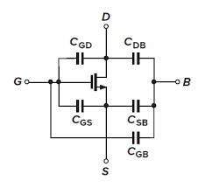

**Figure 36. Practical Model of Mosfet**

In the buck converter, the MOSFET performs a switching operation. The ideal switching operation does not cause loss and fast switching is performed. However, there are parasitic capacitance components inside the actual MOSFET, and the Miller Plateau phenomenon appears in which a flat voltage section exists due to this component when performing a switching operation. That is, there is a section in which switching is not performed immediately and loss occurs. Therefore, noise is generated in this operation period.

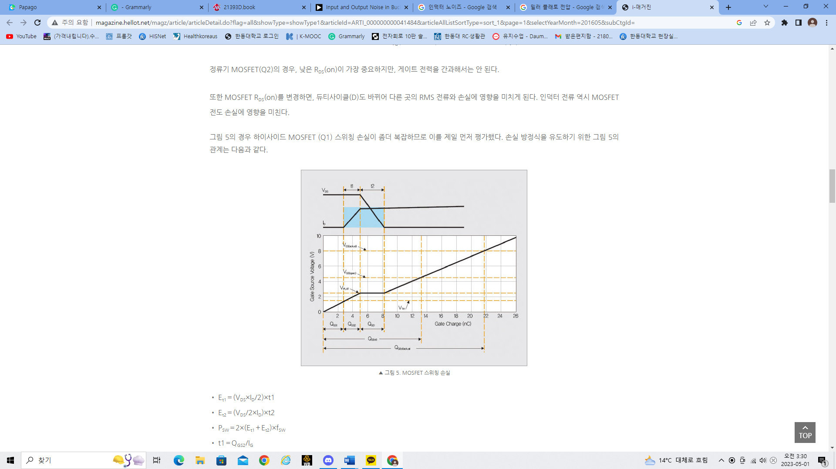

**Figure 37. Miller Plateau Effect of Mosfet**

Due to the Characteristic of the buck converter, noise generated from input and output must be reduced. However, control at the input has little effect, and the best way is to increase the size of the capacitor at the output end. However, the conditions of actual commercialization must be found and applied to the maximum that satisfies both conditions within the economic and engineering condition.

B. High Temperature issue of Gate Driver

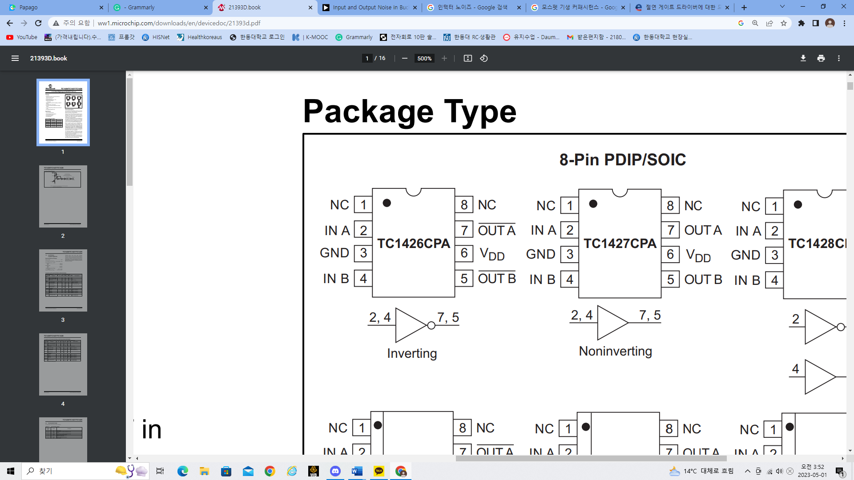

**Figure 38. TC1426 Gate Driver**

The gate driver is used to increase the low voltage of pwm to facilitate the switching action of the MOSFET. The gate driver used in the experiment is the TC1426 model, which raises the PWM voltage to 12V with inversion amplification.

**Figure 39. Thermal Derating Curves of TC1462**

During the experiment, it was confirmed several times that the temperature of the gate driver increased, and as the temperature of the gate driver increased, the original function was lost, affecting the result value. In addition, noise can be seen in this process because the gate driver amplifies the voltage required for MOSFET switching.

**Figure 40. The method of Decrease Noise in Gate Driver**

It is a method of adding resistance to MOSFET and gate driver in the direction of reducing noise in the gate driver. However, since this method can increase the loss of the MOSFET, it is necessary to properly adjust the size of the resistance. Therefore, a resistance of an appropriate size should be used considering the degree of loss of the MOSFET and the level of noise. In addition, there is a problem that it is difficult to use in the case of an internal circuit of this method.

# CONCLUSION

The theoretical meaning of the buck converter is to output a voltage lower than the input. The output ratio is proportional to the D (duty) of the converter, and this experiment was an actual demonstration. In a real circuit, the buck converter produces a lower output than the input, but not proportion about Duty. This results in a loss in the switching behavior of the MOSFET resulting in an experimental value lower than the theoretical value. So, we're going to use an element called bootstrap. By using the bootstrap element, the MOSFET operates normally without any switching loss. In the experiment, the circuit using the bootstrap showed that the experimental and theoretical values were very similar. However, there were cases where errors occurred, and it was analyzed that the loss caused by noise and the heating of the device affected the error. Finally, experiments can show the operating principles of the buck converter and determine why the bootstrap is required for the buck converter.

# WORK DISTRIBUTION

|  |  |  |
| --- | --- | --- |
|  | Hyun ui | Gyeon heal |
| Circuit construction | 50% | 50% |
| Circuit Testing | 60% | 40% |
| Report | 40% | 60% |

# APPENDIX

A picture of the Buck Converter circuit and Bootstrap is shown below.

|  |
| --- |
| **Figure 41. Bootstrap With Buck Converter** |

**Figure 42. Buck Converter**

# REFERENCE

Mosfet

<https://www.electronics-tutorials.ws/transistor/tran_6.html>

Diode

<https://electricalacademia.com/basic-electrical/semiconductor-diode-theory-types-characteristics/>

Capacitor

<https://studiousguy.com/working-principle-of-a-capacitor/>

Bootstrap

<https://techweb.rohm.com/product/power-ic/dcdc/dcdc-evaluation/829/>

Power loss of Mosfet Switching

<http://magazine.hellot.net/magz/article/articleDetail.do?flag=all&showType=showType1&articleId=ARTI_000000000041484&articleAllListSortType=sort_1&page=1&selectYearMonth=201605&subCtgId=>

.Specsheet of TC1426

<http://ww1.microchip.com/downloads/en/devicedoc/21393d.pdf>

The method of Reduce Noise in gate Driver

<https://techweb.rohm.co.kr/product/power-ic/dcdc/dcdc-design/5771/>

Input and Output Noise in Buck Converters Explained

<https://www.analog.com/en/technical-articles/input-and-output-noise-in-buck-converters-explained.html>